MANIPULATOR DESIGN AND CONTROL

Theory: If we drive a robot to a specific position by giving command to robot motors. It often fails to reach the goal precisely. There are several factors that influence robot motion such as robot dynamics, manufacturing tolerances, signal distortions, external forces (friction, payload, surface texture), environmental factors, etc. Robot control is used to manage, command, and direct the robot.

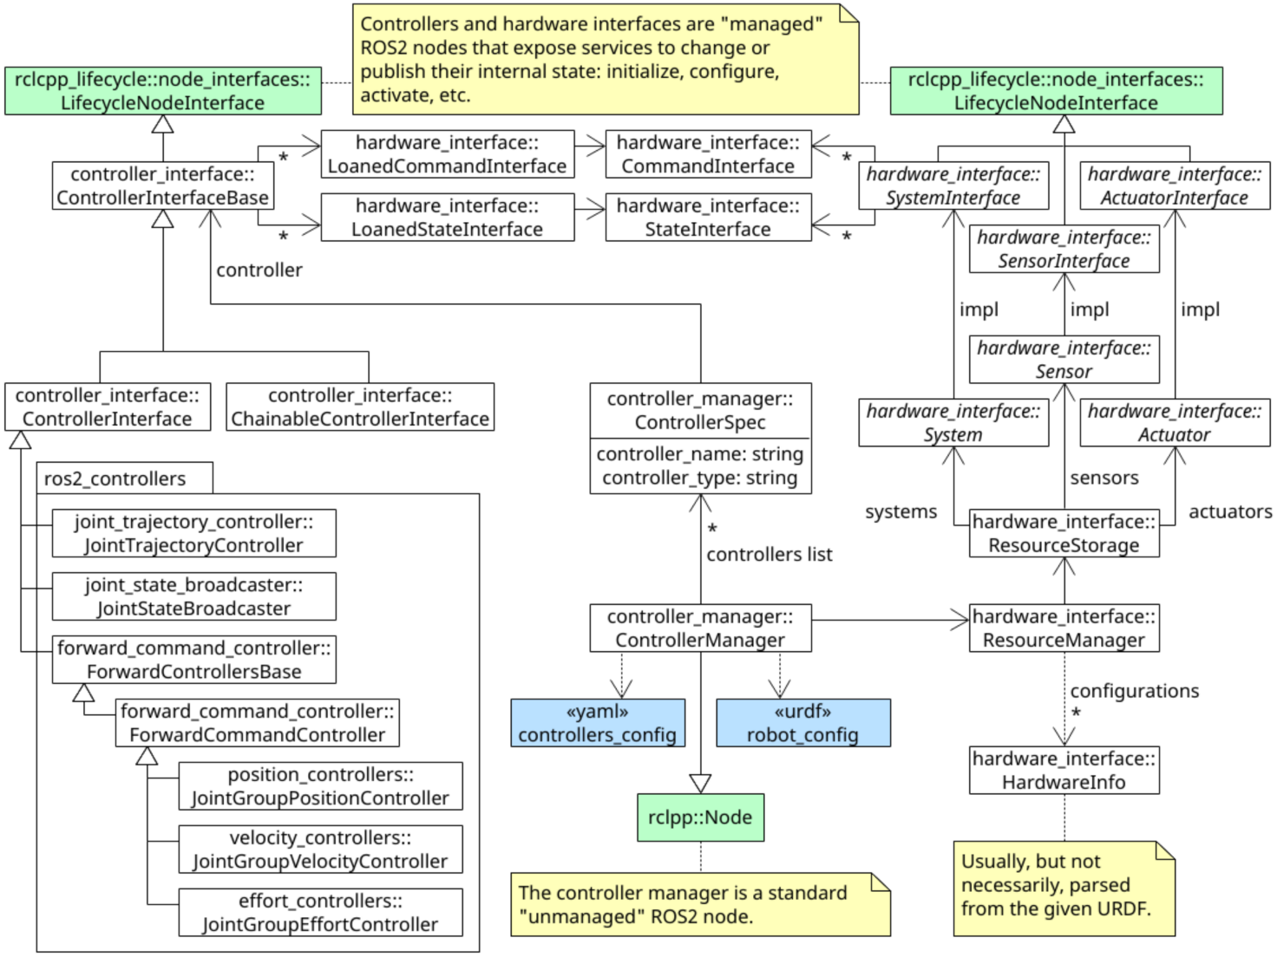

References:

https://github.com/ros-controls/control.ros.org/tree/humble

https://control.ros.org/master/index.html

http://wiki.ros.org/urdf/Tutorials/Adding%20Physical%20and%20Collision%20Properties%20to%20a%20URDF%20Model

Add extensions in Visual Studio

ros
ros snippet
xml
xml tools
urdf
xml complete
icons

Install the following packages

Execute in Terminal #1
sudo apt-get install ros-humble-teleop-twist-keyboard
sudo apt-get install ros-humble-joint-state-publisher*
sudo apt-get install ros-humble-joint-trajectory-controller
sudo apt-get install ros-humble-controller-manager
sudo apt install ros-humble-gazebo-*
sudo apt install ros-humble-gazebo-msgs
sudo apt install ros-humble-gazebo-ros
sudo apt install ros-humble-gazebo-ros2-control-demos
sudo apt install ros-humble-ros2-control
sudo apt install ros-humble-ros2-controllers
sudo apt install ros-humble-ros2controlcli
sudo apt install ros-humble-xacro
sudo apt install ros-humble-gazebo-dev
sudo apt install ros-humble-gazebo-plugins

cd asha_ws/src
ros2 pkg create --build-type ament_python lab5 --dependencies rclpy

cd ..
colcon build --packages-select lab5

cd asha_ws/src/lab5/
mkdir urdf
cd urdf
touch arm.urdf

<?xml version="1.0"?>
<robot name="arm">
<!-- https://www.rapidtables.com/web/color/RGB_Color.html -->
<link name="world"/>
<link name="base_link">
<visual>
<geometry>
<cylinder length="0.05" radius="0.2"/>
</geometry>
<material name="Orange">
<color rgba="1 0.5 0 1"/>
</material>
<origin xyz="0 0 0.025" rpy="0 0 0" />
</visual>

<collision>
<geometry>
<cylinder length="0.05" radius="0.2"/>
</geometry>
<origin xyz="0 0 0.025" rpy="0 0 0" />
</collision>

<inertial>
<origin rpy="0 0 0" xyz="0 0 0.025"/>
<mass value="5.0"/>
<inertia ixx="0.0135" ixy="0.0" ixz="0.0" iyy="0.0135" iyz="0.0" izz="0.05"/>
</inertial>
</link>

<joint name="world_base_joint" type="fixed">
<parent link="world"/>
<child link="base_link"/>
<dynamics damping="10" friction="1.0"/>
</joint>

<link name="arm1_link">
<visual>
<geometry>
<cylinder length="0.5" radius="0.08"/>
</geometry>
<material name="Blue">
<color rgba="0 0 1 1"/>
</material>
<origin xyz="0 0 0.25" rpy="0 0 0" />
</visual>

<collision>
<geometry>
<cylinder length="0.5" radius="0.08"/>
</geometry>
<origin xyz="0 0 0.25" rpy="0 0 0" />
</collision>

<inertial>
<origin rpy="0 0 0" xyz="0 0 0.25"/>
<mass value="5.0"/>
<inertia ixx="0.107" ixy="0.0" ixz="0.0" iyy="0.107" iyz="0.0" izz="0.0125"/>
</inertial>

</link>

<joint name="base_arm1_joint" type="revolute">
<axis xyz="0 1 0"/>
<parent link="base_link"/>
<child link="arm1_link"/>
<origin xyz="0.0 0.0 0.05" rpy="0 0 0" />
<limit lower="-2.14" upper="2.14" effort="100" velocity="100" />
<dynamics damping="10" friction="1.0"/>
</joint>

<link name="arm2_link">
<inertial>
<origin xyz="0 0 0.25" rpy="0 0 0" />
<mass value="0.01"/>
<inertia ixx="0.027" ixy="0.0" ixz="0.0" iyy="0.027" iyz="0.0" izz="0.0025"/>
</inertial>

<visual>
<geometry>
<cylinder length="0.5" radius="0.05"/>
</geometry>
<material name="White">
<color rgba="1 1 1 1"/>
</material>
<origin rpy="0 0 0" xyz="0 0 0.25"/>
</visual>

<collision>
<geometry>
<cylinder length="0.4" radius="0.05"/>
</geometry>
<origin xyz="0 0 0.25" rpy="0 0 0" />
</collision>
</link>

<joint name="arm1_arm2_joint" type="revolute">
<parent link="arm1_link"/>
<child link="arm2_link"/>
<origin xyz="0.0 0.0 0.5" rpy="0 0 0" />
<axis xyz="0 1 0"/>
<limit lower="-2.14" upper="2.14" effort="100" velocity="100" />
<dynamics damping="10" friction="1.0"/>
</joint>

<link name="arm3_link">
<inertial>
<origin xyz="0 0 0.15" rpy="0 0 0" />
<mass value="0.01"/>
<inertia ixx="0.027" ixy="0.0" ixz="0.0" iyy="0.027" iyz="0.0" izz="0.0025"/>
</inertial>
<visual>
<geometry>
<cylinder length="0.3" radius="0.03"/>
</geometry>
<material name="Red">
<color rgba="1 0 0 1"/>
</material>
<origin rpy="0 0 0" xyz="0 0 0.15"/>
</visual>

<collision>
<geometry>
<cylinder length="0.3" radius="0.03"/>
</geometry>
<origin xyz="0 0 0.15" rpy="0 0 0" />
</collision>
</link>

<joint name="arm2_arm3_joint" type="revolute">
<parent link="arm2_link"/>
<child link="arm3_link"/>
<origin xyz="0.0 0.0 0.5" rpy="0 0 0" />
<axis xyz="0 1 0"/>
<limit lower="-2.14" upper="2.14" effort="100" velocity="100" />
<dynamics damping="10" friction="1.0"/>
</joint>

<gazebo reference="base_link">
<material>Gazebo/Orange</material>
</gazebo>

<gazebo reference="arm1_link">
<material>Gazebo/Blue</material>
</gazebo>

<gazebo reference="arm2_link">
<material>Gazebo/White</material>
</gazebo>

<gazebo reference="arm3_link">
<material>Gazebo/Red</material>
</gazebo>

<gazebo>
<plugin filename="libgazebo_ros2_control.so" name="gazebo_ros2_control">
<robot_sim_type>gazebo_ros2_control/GazeboSystem</robot_sim_type>
<parameters>/home/asha/asha_ws/src/lab5/config/control.yaml</parameters>
</plugin>
</gazebo>

<ros2_control name="GazeboSystem" type="system">
<hardware>
<plugin>gazebo_ros2_control/GazeboSystem</plugin>
</hardware>

<joint name="base_arm1_joint">
<command_interface name="position">
<param name="min">-2.14</param>
<param name="max">2.14</param>
</command_interface>
<state_interface name="position"/>
<param name="initial_position">0.0</param>
</joint>
<joint name="arm1_arm2_joint">
<command_interface name="position">
<param name="min">-2.14</param>
<param name="max">2.14</param>
</command_interface>
<state_interface name="position"/>
<param name="initial_position">0.1</param>
</joint>
<joint name="arm2_arm3_joint">
<command_interface name="position">
<param name="min">-2.14</param>
<param name="max">2.14</param>
</command_interface>
<state_interface name="position"/>
<param name="initial_position">0.2</param>
</joint>

</ros2_control>

</robot>

cd ..
mkdir launch
cd launch
touch rviz.launch.py

from launch import LaunchDescription
from launch_ros.actions import Node

def generate_launch_description():

urdf_file = urdf = '/home/asha/asha_ws/src/lab5/urdf/arm.urdf'

joint_state_publisher_node = Node(
package="joint_state_publisher_gui",
executable="joint_state_publisher_gui",
name="joint_state_publisher_gui",
output="screen",
arguments=[urdf_file]
)
robot_state_publisher_node = Node(
package="robot_state_publisher",
executable="robot_state_publisher",
name="robot_state_publisher",
output="screen",
arguments=[urdf_file]
)
rviz_node = Node(
package="rviz2",
executable="rviz2",
name="rviz2",
output="screen"
)

nodes_to_run = [
joint_state_publisher_node,
robot_state_publisher_node,
rviz_node
]

return LaunchDescription(nodes_to_run)

touch gazebo.launch.py

import os
from launch import LaunchDescription
from launch.actions import ExecuteProcess
from launch_ros.actions import Node

def generate_launch_description():
urdf_file = '/home/asha/asha_ws/src/lab5/urdf/arm.urdf'

return LaunchDescription(
[
ExecuteProcess(
cmd=["gazebo","-s","libgazebo_ros_factory.so",],
output="screen",
),
Node(
package="gazebo_ros",
executable="spawn_entity.py",
arguments=["-entity","urdf_tutorial","-b","-file", urdf_file],
),
Node(
package="robot_state_publisher",
executable="robot_state_publisher",
output="screen",
arguments=[urdf_file],
),

]
)
cd ~/asha_ws/src/lab5
mkdir config
cd config
touch control.yaml

controller_manager:
ros__parameters:
update_rate: 100
joint_state_broadcaster:
type: joint_state_broadcaster/JointStateBroadcaster
joint_trajectory_controller:
type: joint_trajectory_controller/JointTrajectoryController

joint_trajectory_controller:
ros__parameters:
joints:
- base_arm1_joint
- arm1_arm2_joint
- arm2_arm3_joint

command_interfaces:
- position

state_interfaces:
- position

state_publish_rate: 50.0
action_monitor_rate: 20.0

allow_partial_joints_goal: false
open_loop_control: true
constraints:
stopped_velocity_tolerance: 0.01
goal_time: 0.0
joint1:
trajectory: 0.05
goal: 0.03

touch arm.launch.py
edit arm.launch.py

import os
from launch import LaunchDescription
from launch.actions import ExecuteProcess, IncludeLaunchDescription, RegisterEventHandler
from launch_ros.actions import Node
from launch.event_handlers import OnProcessExit
from launch.launch_description_sources import PythonLaunchDescriptionSource
from ament_index_python.packages import get_package_share_directory

import xacro

def generate_launch_description():

urdf_file = '/home/asha/asha_ws/src/lab5/urdf/arm.urdf'
controller_file = '/home/asha/asha_ws/src/lab5/config/control.yaml'
robot_description = {"robot_description": urdf_file}

gazebo = IncludeLaunchDescription(
PythonLaunchDescriptionSource([os.path.join(
get_package_share_directory('gazebo_ros'), 'launch'), '/gazebo.launch.py']),
)

doc = xacro.parse(open(urdf_file))
xacro.process_doc(doc)
params = {'robot_description': doc.toxml()}

node_robot_state_publisher = Node(
package='robot_state_publisher',
executable='robot_state_publisher',
output='screen',
parameters=[params]
)

spawn_entity = Node(package='gazebo_ros', executable='spawn_entity.py',
arguments=["-entity","lab5","-b","-file", urdf_file],
output='screen'
)

load_joint_state_controller = ExecuteProcess(
cmd=['ros2', 'control', 'load_controller', '--set-state', 'active', 'joint_state_broadcaster'],
output='screen'
)

load_joint_trajectory_controller = ExecuteProcess(
cmd=['ros2', 'control', 'load_controller', '--set-state', 'active', 'joint_trajectory_controller'],
output='screen'
)

return LaunchDescription(
[
RegisterEventHandler(
event_handler=OnProcessExit(
target_action=spawn_entity,
on_exit=[load_joint_state_controller],
)
),

RegisterEventHandler(
event_handler=OnProcessExit(
target_action=load_joint_state_controller,
on_exit=[load_joint_trajectory_controller],
)
),

gazebo,

node_robot_state_publisher,

spawn_entity,

Node(
package="controller_manager",
executable="ros2_control_node",
parameters=[robot_description, controller_file],
output="screen"
)
]
)

Execute in Terminal #1
colcon build --packages-select lab5 --symlink-install
Execute in Terminal #1
ros2 launch lab5 rviz.launch.py
Execute in Terminal #2
ros2 launch lab5 gazebo.launch.py
ctrl+c
Execute in Terminal #3
ros2 launch lab5 arm.launch.py

cd asha_ws/src/lab5/lab5/
touch controller.py
chmod +x controller.py

#!/usr/bin/env python3

#colcon build --packages-select lab5 –symlink-install
#ros2 run lab5 control --ros-args -p end_location:=[0.15,0.5,-0.2]

import rclpy
from rclpy.node import Node
from builtin_interfaces.msg import Duration
from trajectory_msgs.msg import JointTrajectory, JointTrajectoryPoint

class TrajectoryPublisher(Node):

def __init__(self):
super().__init__('trajectory_node')
topic_ = "/joint_trajectory_controller/joint_trajectory"
self.joints = ['base_arm1_joint', 'arm1_arm2_joint', 'arm2_arm3_joint']
self.goal_ =[0.0, 0.0, 0.75]
#self.declare_parameter("joint_angles", [1.5, 0.5, 1.2])
#self.goal_=self.get_parameter("joint_angles").value
self.publisher_ = self.create_publisher(JointTrajectory, topic_, 10)
self.timer_ = self.create_timer(1,self.timer_callback)

def timer_callback(self):
msg = JointTrajectory()
msg.joint_names = self.joints
point = JointTrajectoryPoint()
point.positions = self.goal_
point.time_from_start = Duration(sec=2)
msg.points.append(point)
self.publisher_.publish(msg)

def main(args=None):
rclpy.init(args=args)
node = TrajectoryPublisher()
rclpy.spin(node)
node.destroy_node()
rclpy.shutdown()

if __name__ == '__main__':
main()

Edit setup.py as

from setuptools import find_packages, setup
import os
from glob import glob
package_name = 'lab5'

setup(
name=package_name,
version='0.0.0',
packages=find_packages(exclude=['test']),
data_files=[
('share/ament_index/resource_index/packages',
['resource/' + package_name]),
('share/' + package_name, ['package.xml']),
(os.path.join('share',package_name),glob('launch/*')),
(os.path.join('share',package_name),glob('urdf/*')),
(os.path.join('share',package_name),glob('config/*')),

],
install_requires=['setuptools'],
zip_safe=True,
maintainer='asha',
maintainer_email='asha@todo.todo',
description='TODO: Package description',
license='TODO: License declaration',
tests_require=['pytest'],
entry_points={
'console_scripts': [
'control=lab5.controller:main'
],
},
))

Execute in Terminal #1
colcon build --packages-select lab5 –symlink-install
Execute in Terminal #1
ros2 launch lab5 rviz.launch.py
Execute in Terminal #2
ros2 launch lab5 arm.launch.py
Execute in Terminal #3
ros2 run lab5 control

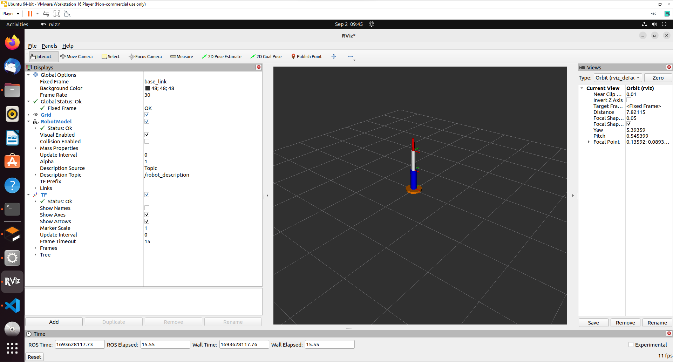

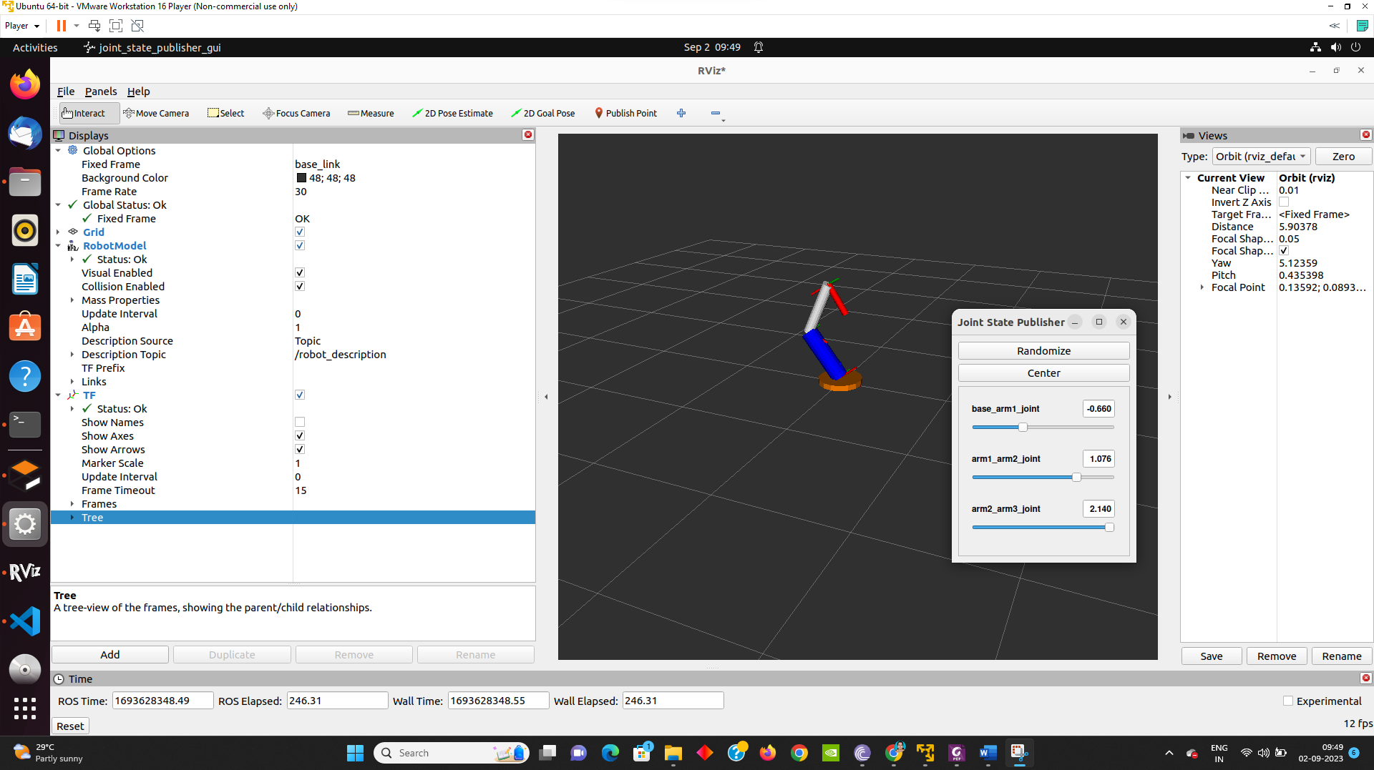

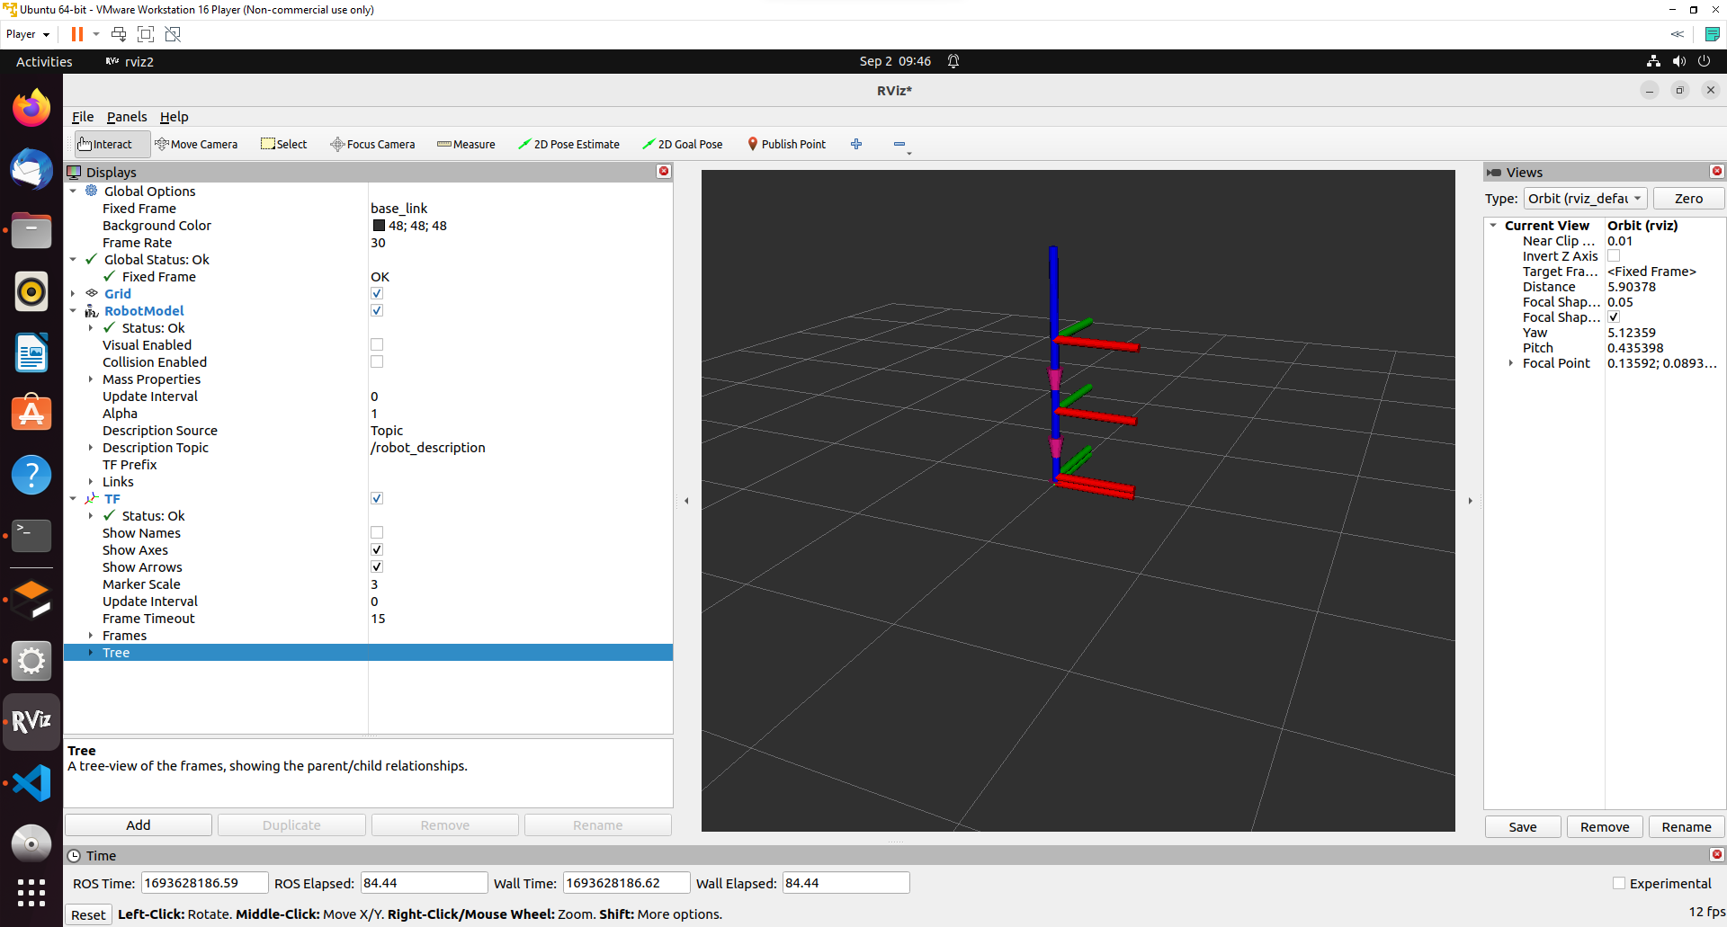

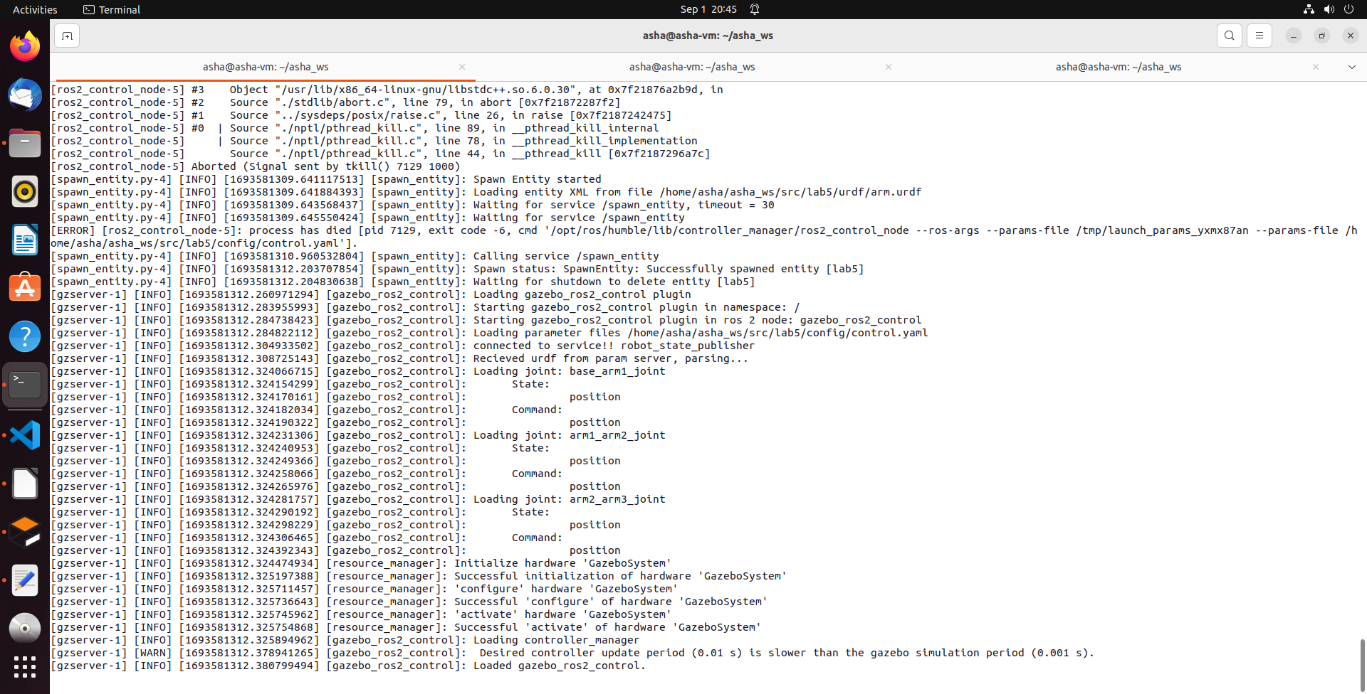

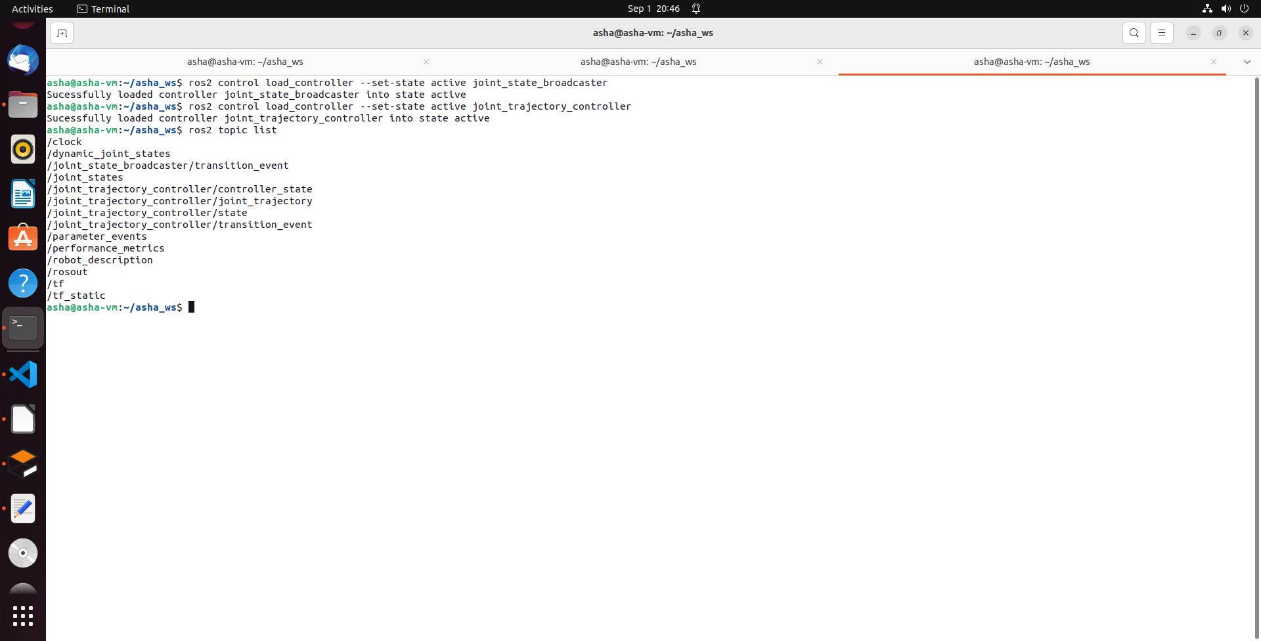

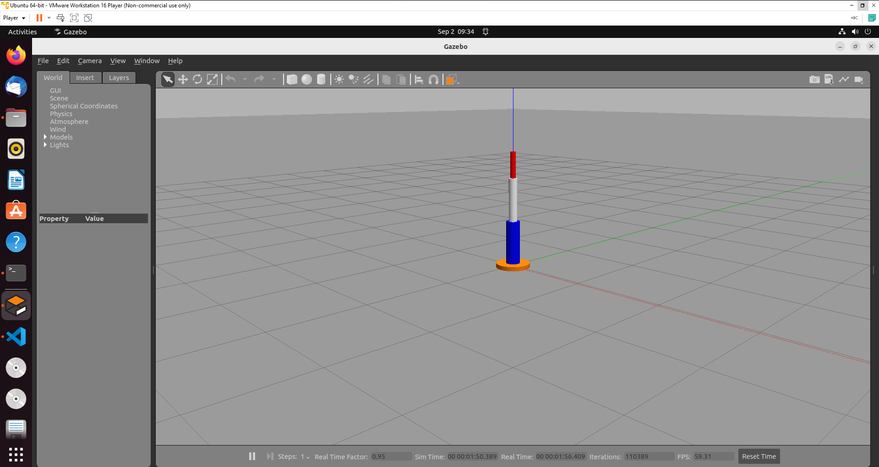

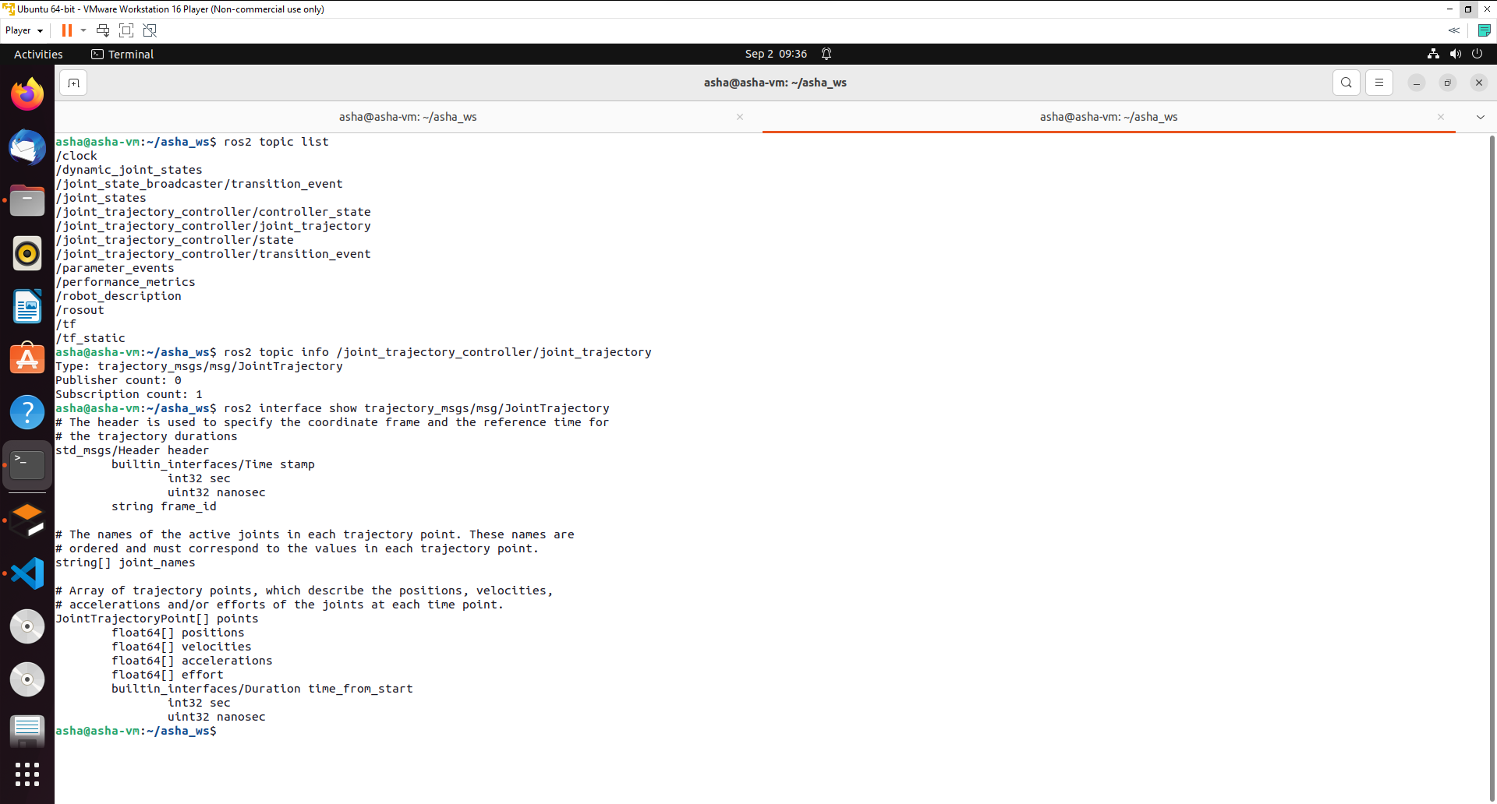

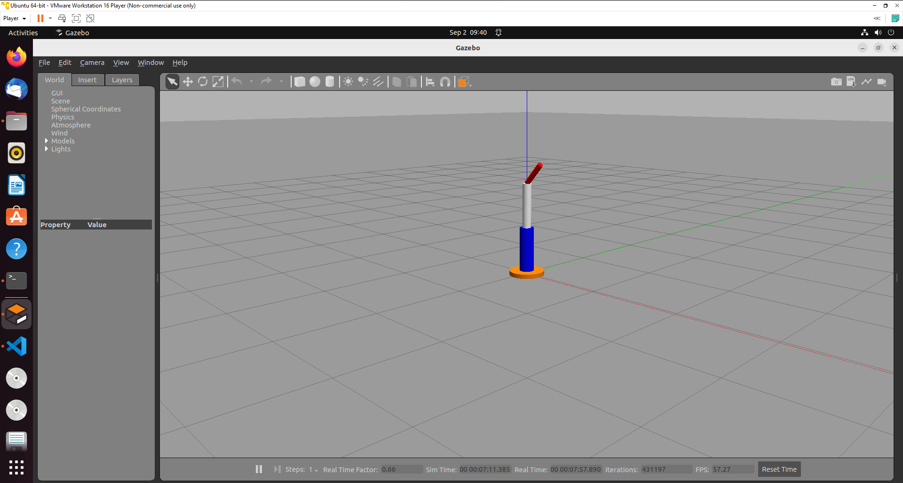

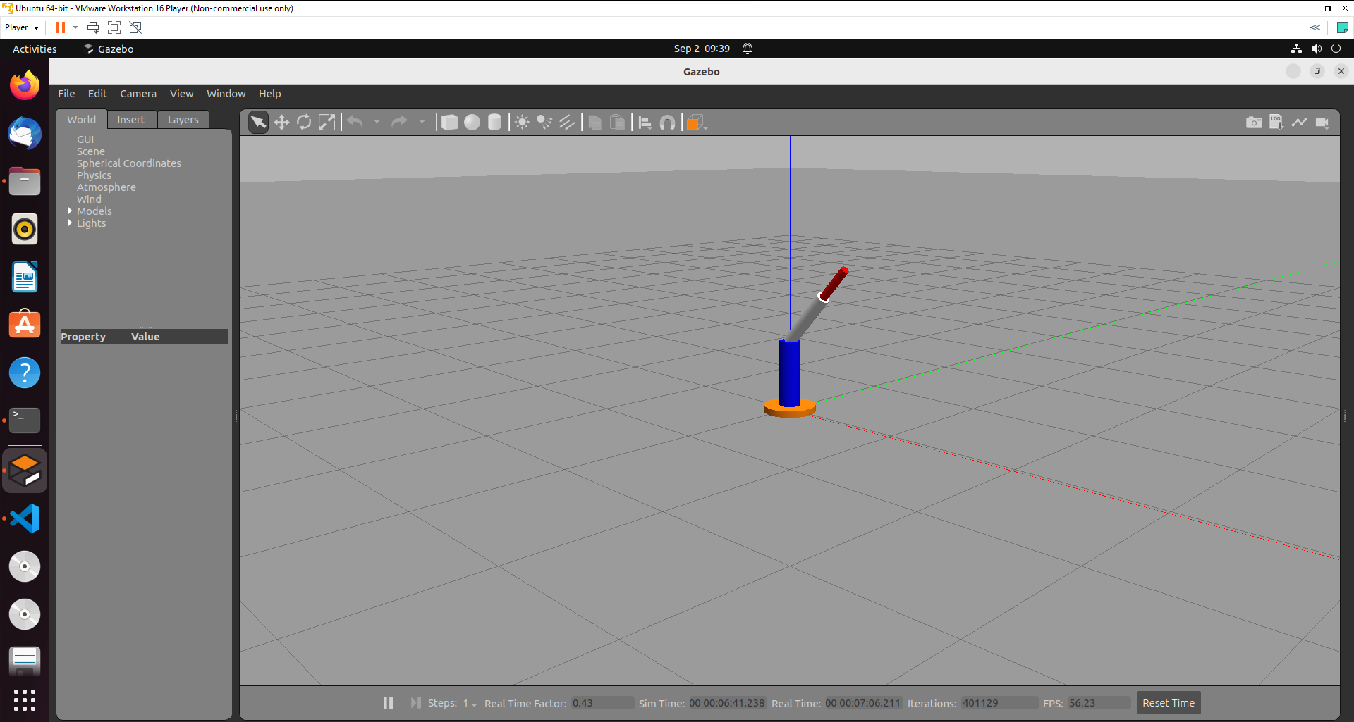

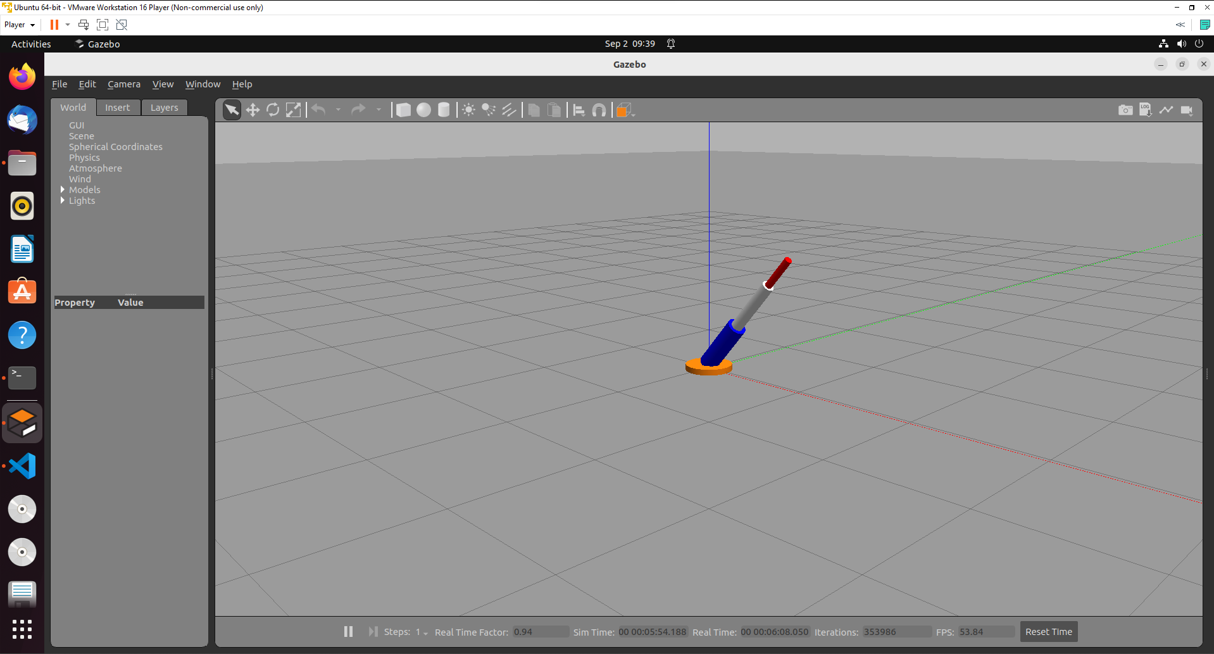

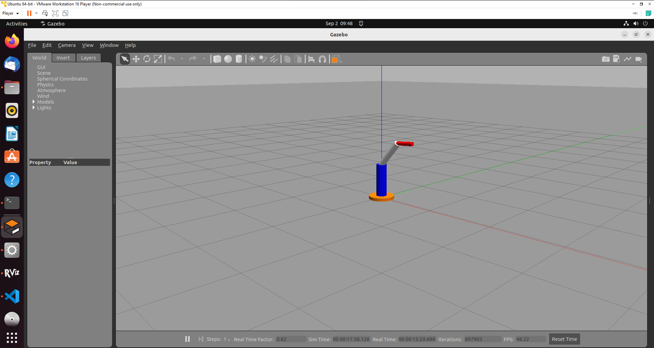

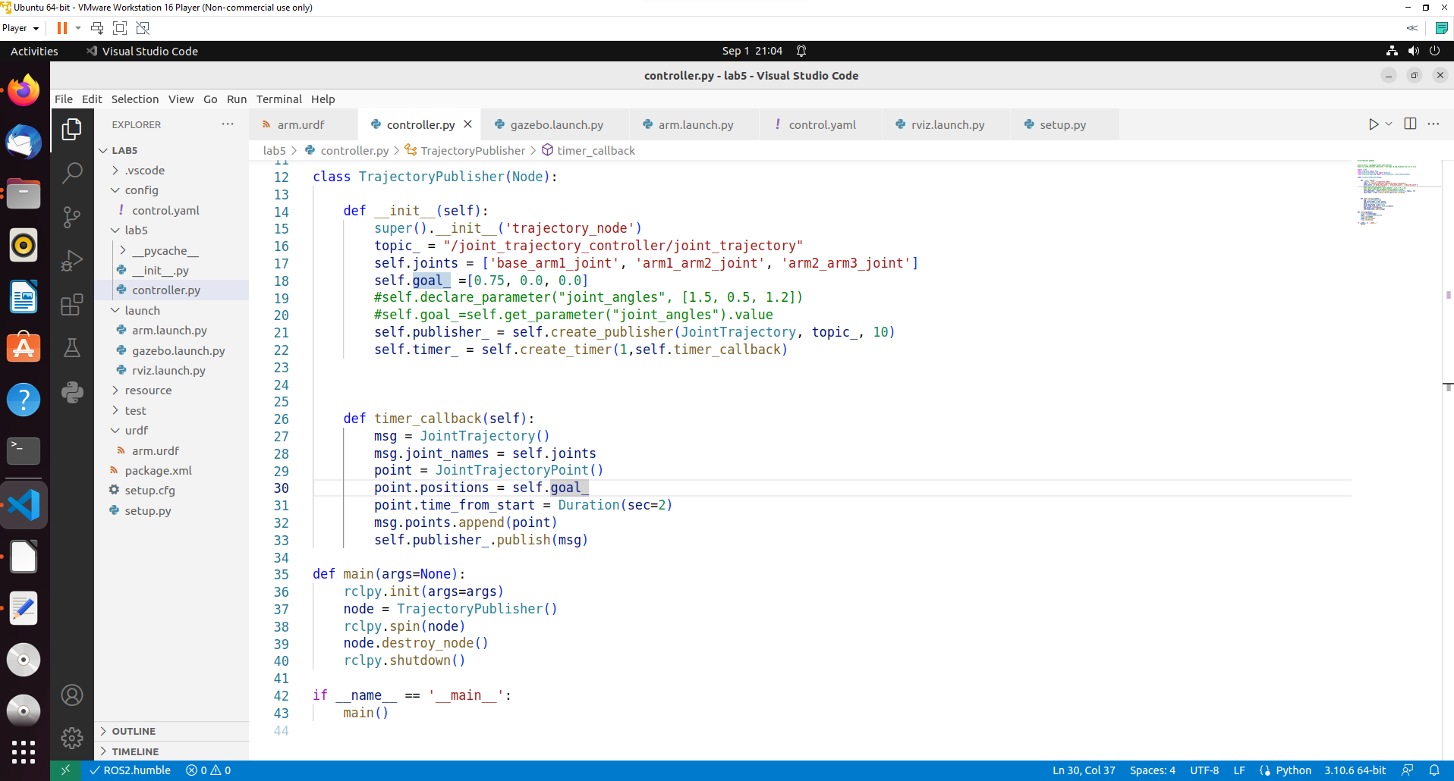

ROS2 parameters:

Parameters help to provide the values while running the code.

ros2 param list

#!/usr/bin/env python3

#colcon build --packages-select lab5 --symlink-install
#ros2 run lab5 control --ros-args -p end_location:=[0.15,0.5,-0.2]

import rclpy
from rclpy.node import Node
from builtin_interfaces.msg import Duration
from trajectory_msgs.msg import JointTrajectory, JointTrajectoryPoint

class TrajectoryPublisher(Node):

def __init__(self):
super().__init__('trajectory_node')
topic_ = "/joint_trajectory_controller/joint_trajectory"
self.joints = ['base_arm1_joint', 'arm1_arm2_joint', 'arm2_arm3_joint']
#self.goal_ =[0.0, 0.0, 0.75]
self.declare_parameter("joint_angles", [1.5, 0.5, 1.2])
self.goal_=self.get_parameter("joint_angles").value
self.publisher_ = self.create_publisher(JointTrajectory, topic_, 10)
self.timer_ = self.create_timer(1,self.timer_callback)

def timer_callback(self):
msg = JointTrajectory()
msg.joint_names = self.joints
point = JointTrajectoryPoint()
point.positions = self.goal_
point.time_from_start = Duration(sec=2)
msg.points.append(point)
self.publisher_.publish(msg)

def main(args=None):
rclpy.init(args=args)
node = TrajectoryPublisher()
rclpy.spin(node)
node.destroy_node()
rclpy.shutdown()

if __name__ == '__main__':
main()

Execute in Terminal #1
colcon build --packages-select lab5 --symlink-install
Execute in Terminal #2
ros2 launch lab5 arm.launch.py
ros2 control load_controller --set-state active joint_state_broadcaster
ros2 control load_controller --set-state active joint_trajectory_controller

Execute in Terminal #3
ros2 run lab5 control --ros-args -p joint_angles:=[0.5,0.5,0.2]

Exercise 1: Write a python code to move the manipulator to end location using inverse kinematics.

Exercise 2: Rewrite the complete code using xacro (optional).

Exercise 3: Replicate the process for UR5e robot given its urdf file (optional).

References

https://docs.ros.org/en/humble/Tutorials/URDF/Using-URDF-with-Robot-State-Publisher.html
https://github.com/benbongalon/ros2-urdf-tutorial/tree/master/urdf_tutorial
https://github.com/cra-ros-pkg/robot_localization/tree/humble-devel
https://github.com/ros/robot_state_publisher/tree/humble
https://github.com/ros/joint_state_publisher/tree/humble
http://gazebosim.org/tutorials?tut=ros_urdf

